Chapter 5 Network Layer: Control Plane
------------------------------------------------------------------------------------------------------------------------
- ▪introduction
  - 1. Per-Router Control Plane:
Each router makes its own forwarding and routing decisions independently using its local routing algorithms and information exchanged with neighboring routers (e.g., via OSPF, RIP, BGP).
  - 2. SDN (Software-Defined Networking) Control Plane:
A centralized controller (separate from routers) manages routing and forwarding decisions for the entire network. Routers (or switches) simply follow the instructions from this controller.
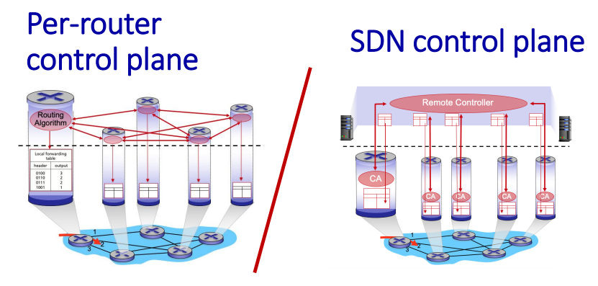
- ▪ routing protocols
- Routing protocol goal: determine “good” paths from sending hosts to receiving host, through network of routers
- path: sequence of routers packets traverses from given initial source host to destination host
- “good”: least “cost”, “fastest”, “least congested”
- routing: a “top 10” networking challenge
- Global (Link State) → Full network view, centralized computation per router.
- Decentralized (Distance Vector) → Partial network view, iterative updates with neighbours.
- Static → Fixed routes.
- Dynamic → Adaptive routes
  - ▪ link state
Dijkstra’s Link State Routing algorithm
- centralized: network topology, link costs known to all nodes
  - accomplished via “link state broadcast”
  - all nodes have same info
- computes least cost paths from one node (“source”) to all other nodes
- gives forwarding table for that node
- iterative: after k iterations, know least cost path to k destinations
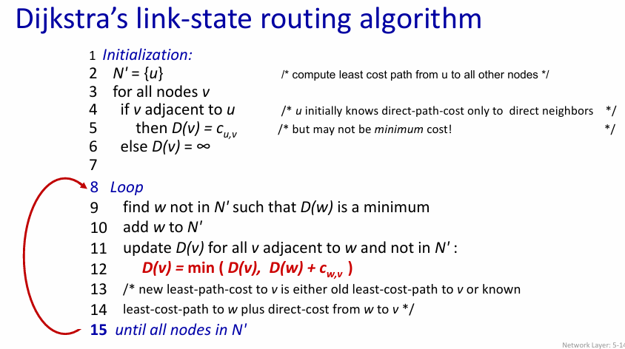
D(v) = min ( D(v), D(w) + cw,v )
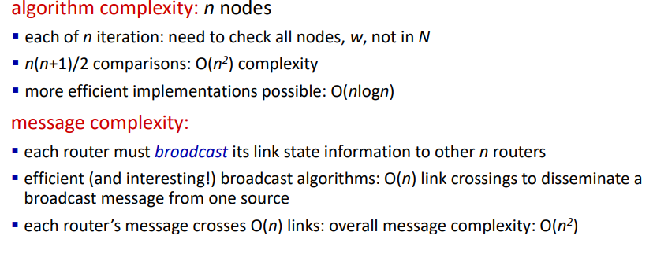
oscillations possible –
when link costs depend on traffic volume, route oscillations possible
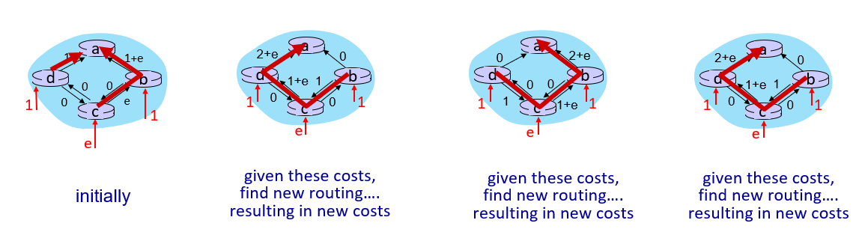

  - ▪ distance vector
Aspect | Link State (LS) | Distance Vector (DV)
Information Used | Global — all routers know full topology and link costs | Local — routers know only neighbors’ costs
Message Complexity | $O(n^{2})$messages for n routers | Exchanges only between neighbors; message count and convergence vary
Speed of Convergence | $O(n^{2})$time; may cause oscillations | Convergence time varies; may have routing loops and count-to-infinity problem
Robustness | If a router advertises incorrect link cost, it affects only its own computation | If a router advertises wrong path cost, error propagates through the network (black-holing possible)
Computation | Each router computes its own shortest paths (e.g., Dijkstra) | Each router updates distances iteratively (e.g., Bellman-Ford)
Example Protocols | OSPF, IS-IS | RIP

Based on Bellman-Ford (BF) equation (dynamic programming):
Let Dx(y): cost of least-cost path from x to y. Then: Dx(y) = min { cx,v + Dv(y) }
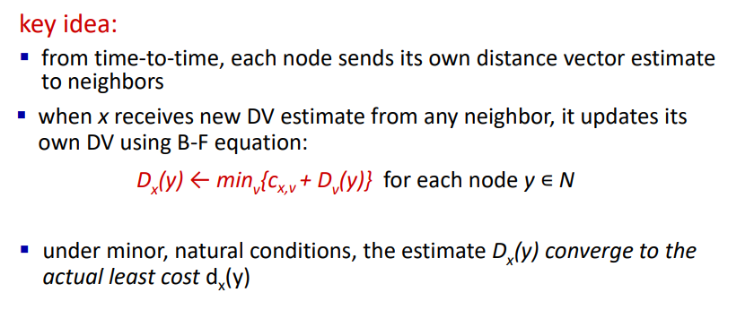
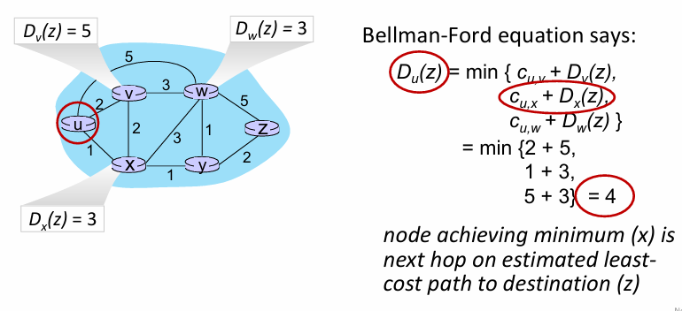

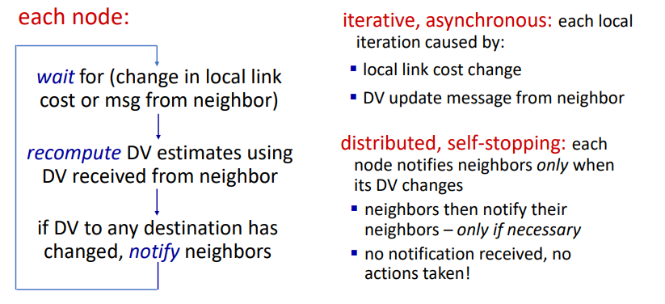
In Distance Vector Routing, every router tells its neighbors the cost to reach all other routers.
✅ Good news travels fast
When a link cost decreases, updates spread quickly.
Example:
x —— y —— z
- Suppose link cost y–x changes from 4 → 1.
- y updates its table and informs z.
- z recalculates its cost to x (now smaller) and updates too.
Since costs are improving, routers quickly accept the update —
that’s why “good news travels fast.”

⚠️ Bad news travels slow (Count-to-Infinity Problem)
When a link cost increases or breaks, routers can mislead each other using old info.
Example:
x —— y —— z
- Originally: y–x = 4, y–z = 1, z–x = 5
- Then y–x becomes 60 (bad link).
- y thinks: “z can reach x in 5, so my cost via z = 1 + 5 = 6.”
- z then thinks: “y can reach x in 6, so my cost = 1 + 6 = 7.”
- y updates again: 8 … then 9 … and so on.
This endless loop of increasing values is the count-to-infinity problem, meaning “bad news travels slow.”

💡 Fixes: Modern routing protocols use
Split Horizon, Poison Reverse, and Hold-Down Timers to stop such loops.

- ▪ intra-ISP routing: OSPF

Making Routing Scalable
- The Internet has billions of destinations:
  - Routers can’t store all destinations in routing tables.
  - Routing table exchanges would overload links.
- Administrative autonomy:
  - The Internet is a network of networks.
  - Each network’s admin may want independent routing control.

2. Internet Approach to Scalable Routing
Autonomous Systems (AS)
- The Internet is divided into regions called Autonomous Systems (AS) (also called domains).
- Each AS is administered independently.
Two Types of Routing
(a) Intra-AS Routing (Intra-Domain)
- Routing within the same AS.
- All routers in an AS must run the same intra-domain routing protocol.
- Routers in different ASes can use different intra-domain protocols.
- Gateway routers:
  - Located at the edge of their AS.
  - Have links to routers in other ASes.
(b) Inter-AS Routing (Inter-Domain)
- Routing between ASes.
- Gateway routers participate in inter-domain routing in addition to intra-domain routing.

3. Interaction Between Intra-AS and Inter-AS Routing
Aspect | Description
Forwarding Table Configuration | Determined by both intra-AS and inter-AS routing algorithms.
Intra-AS Routing | Determines entries for destinations within the AS.
Inter-AS + Intra-AS Routing | Together determine entries for external destinations.

4. Inter-AS Routing: Role in Intra-Domain Forwarding
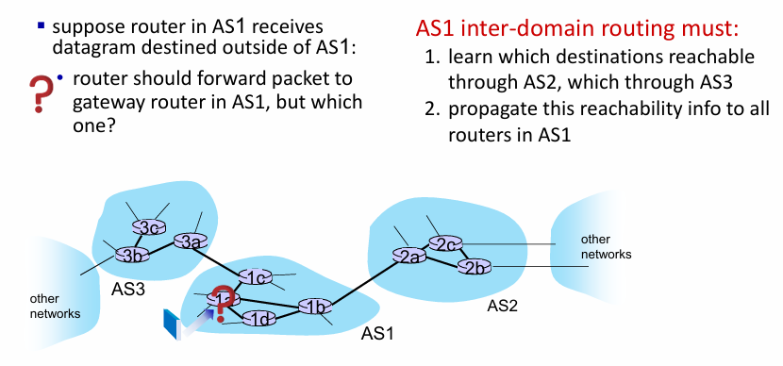

5. Intra-AS Routing (Routing Within an AS)
Common Intra-AS Routing Protocols
Protocol | Type | Key Features
RIP (Routing Information Protocol) [RFC 1723] | Distance Vector (DV) | - Classic DV protocol- DVs exchanged every 30 seconds- Obsolete (no longer widely used)
EIGRP (Enhanced Interior Gateway Routing Protocol) | Distance Vector (DV) | - DV-based,
OSPF (Open Shortest Path First) [RFC 2328] | Link-State | - Publicly available ("open")- Uses Dijkstra’s algorithm- Multiple link cost metrics (bandwidth, delay)

6. OSPF (Open Shortest Path First) Routing
Key Characteristics
- Open: Publicly available protocol.
- Link-State Based:
  - Each router floods link-state advertisements (LSAs) to all other routers in the AS (sent directly over IP, not TCP/UDP).
  - Each router builds a complete network topology map.
  - Uses Dijkstra’s algorithm to compute the shortest paths and fill its forwarding table.
- Multiple Metrics:
  - Can consider bandwidth, delay, etc.
- Security:
  - All OSPF messages are authenticated to prevent malicious tampering.

7. Hierarchical OSPF
Two-Level Hierarchy
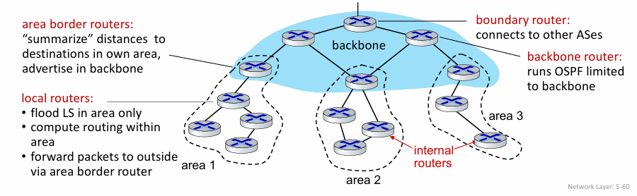

- ▪ routing among ISPs: BGP

Interconnected Autonomous Systems (ASes)
2. Internet Inter-AS Routing: Border Gateway Protocol (BGP)
BGP Overview
- BGP (Border Gateway Protocol) is the de facto inter-domain routing protocol of the Internet.
- Often called the “glue that holds the Internet together.”
Functions of BGP
BGP allows each AS to:
- Advertise its existence and the destinations it can reach:
  - “I am here; here’s who I can reach and how.”
- Obtain reachability information from neighboring ASes (via eBGP).
- Determine routes to other networks based on:
  - Reachability info, and
  - Local routing policies.
- Propagate reachability within its AS (via iBGP).
- Advertise reachability to external ASes.

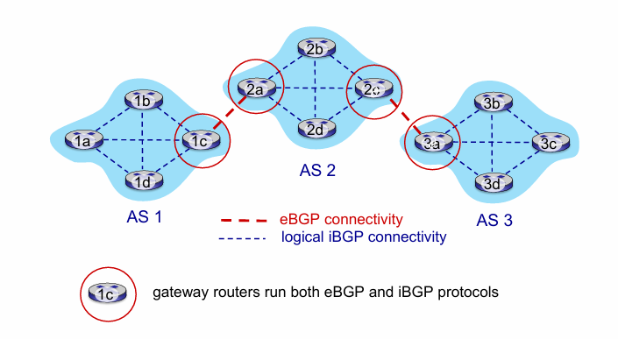

4. BGP Basics
How It Works
- Suppose AS3 gateway 3a advertises path (AS3, X) to AS2 gateway 2c:
  - AS3 promises AS2 it will forward datagrams toward destination X.
- BGP Session:
  - A semi-permanent TCP connection between two BGP peers.
  - Peers exchange BGP messages containing advertisements of network prefixes.
  - BGP is a Path Vector Protocol — each route includes the full AS path.

5. BGP Protocol Messages (Defined in RFC 4371)
Message Type | Function
OPEN | Establishes a TCP session and authenticates peers.
UPDATE | Advertises new paths or withdraws old ones.
KEEPALIVE | Keeps the session active (sent periodically); also acknowledges OPEN.
NOTIFICATION | Reports errors and closes the connection.

6. Path Attributes and BGP Routes
A BGP route = Prefix + Attributes
Key Attributes
- AS-PATH – list of ASes a route advertisement has passed through.
  - Used for loop prevention and policy decisions.
- NEXT-HOP – indicates the specific internal router to use when forwarding to the next AS.
Policy-Based Routing
- Each AS applies import policies:
  - Accept or reject routes (e.g., “never route through AS Y”).
- AS export policies decide whether to advertise routes to other ASes.
  - Enables control over traffic flow and business relationships.

7. BGP Path Advertisement Example
Normal Case
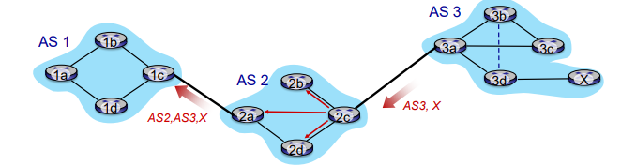
- AS2 router 2c receives path advertisement AS3,X (via eBGP) from AS3 router 3a
- based on AS2 policy, AS2 router 2c accepts path AS3,X, propagates (via iBGP) to all AS2 routers
- based on AS2 policy, AS2 router 2a advertises (via eBGP) path AS2, AS3, X to AS1 router 1c
Multiple Path
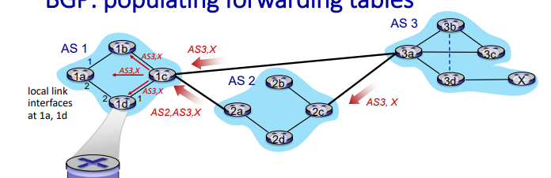
gateway router may learn about multiple paths to destination:
- AS1 gateway router 1c learns path AS2,AS3,X from 2a
- AS1 gateway router 1c learns path AS3,X from 3a
- based on policy, AS1 gateway router 1c chooses path AS3,X and advertises path within AS1 via iBGP

10. Hot Potato Routing
- A router may learn multiple gateways to a destination (e.g., 2a and 2c).
- Hot Potato Routing:
  - Choose the gateway with the least intra-domain cost, regardless of inter-domain path length.
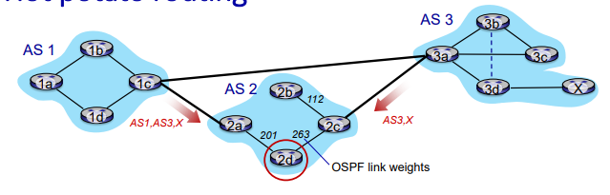
  - Example:
    - AS2 router 2d has two gateways to X (via 2a, 2c).
    - Chooses the nearest one (lowest OSPF cost) to reduce internal load.
- Focus: Minimize internal (intra-AS) cost, not total AS hops.

11. Achieving Policy via BGP Advertisements
Example 1 – Provider-Customer Policy
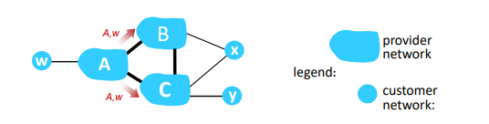
- B gets no “revenue” for routing CBAw, since none of C, A, w are B’s customers
- C does not learn about CBAw path

Example 2 – Dual-Homed Customer Policy
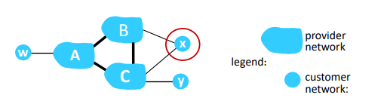
- policy to enforce: x does not want to route from B to C via x
- .. so x will not advertise to B a route to C

12. BGP Route Selection Criteria
When multiple routes to a destination exist, BGP chooses based on:
Priority | Criterion | Description
1 | Local Preference | Highest value preferred; used for policy-based decision.
2 | Shortest AS-PATH | Fewer AS hops preferred.
3 | Closest NEXT-HOP (Hot Potato) | Lowest intra-domain cost to reach next hop.
4 | Other Tiebreakers | e.g., router ID, origin type, etc.

13. Why Separate Intra-AS and Inter-AS Routing?
Aspect | Intra-AS Routing | Inter-AS Routing
Policy | Single administrative control → minimal policy conflicts. | Different admins → must enforce policies (who carries whose traffic).
Scale | Within one AS → simpler, smaller tables. | Across Internet → hierarchical routing reduces table size and updates.
Performance Focus | Emphasis on optimal paths and low delay. | Emphasis on policy and control rather than raw performance.

- ▪ SDN control plane

Software Defined Networking (SDN)

1. Traditional Internet Network Layer is implemented as Distributed, Per-Router Control
Historically, the Internet’s control plane was distributed:
- Each router contained:
  - Switching hardware (data plane)
  - Control software implementing routing protocols (IP, RIP, OSPF, IS-IS, BGP)
- Each vendor implemented proprietary router OS (e.g., Cisco IOS).
- Middleboxes (firewalls, load balancers, NATs, etc.) handled specialized network functions separately.
Drawbacks:
- Closed, vendor-specific systems.
- Complex management (misconfigurations common).
- Difficult traffic engineering and innovation.

2. Rethinking the Control Plane (~2005 Onwards)
Renewed interest in redefining the network control plane led to the idea of Software-Defined Networking (SDN).

3. Traditional Per-Router Control Plane
- Each router ran its own routing algorithm component.
- Routers interacted with each other to compute forwarding tables through distributed protocols.
- Limited global view → difficult to coordinate and optimize network-wide behavior.

4. SDN Control Plane Concept
- A remote (centralized) controller computes and installs forwarding tables in routers/switches.
- Switches perform data forwarding only.
Key Difference
Traditional | SDN
Control plane distributed across routers | Control plane logically centralized in controller
Each router computes its table | Controller computes all tables and installs them

5. Why a Logically Centralized Control Plane?
Advantages
- Simplified network management:
  - Avoid router misconfigurations.
  - Global view enables smarter decisions.
- Programmable forwarding:
  - Table-based forwarding (e.g., via OpenFlow API).
  - Centralized “programming” of routing tables.
- Open, non-proprietary implementation:
  - Promotes innovation and experimentation.
Analogy:
Similar to the mainframe → PC revolution:
Traditional Networks | SDN
Vertically integrated (specialized hardware, OS, apps) | Horizontal layers with open interfaces
Proprietary, slow innovation | Rapid innovation, large open ecosystem

6. Traffic Engineering Challenges in Traditional Networks
Example Questions:
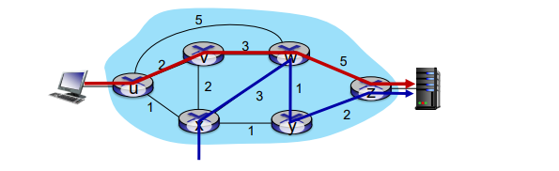
- Force specific path:
  - How to make traffic from u → z follow u–v–w–z instead of u–x–y–z?
  - need to re-define link weights so traffic routing algorithm computes routes accordingly
  - Only control knob = link weights, making control hard.
- Split traffic for load balancing:
  - Split u → z traffic along two paths (u–v–w–z and u–x–y–z)? → Difficult.
- Different treatment for different flows:
  - If w wants to route “blue” and “red” traffic differently → Impossible with destination-based routing.
Conclusion:
Traditional routing (DV/LS) is limited.
→ SDN enables generalized flow-based forwarding to achieve any desired routing behavior.

- Key Features of SDN
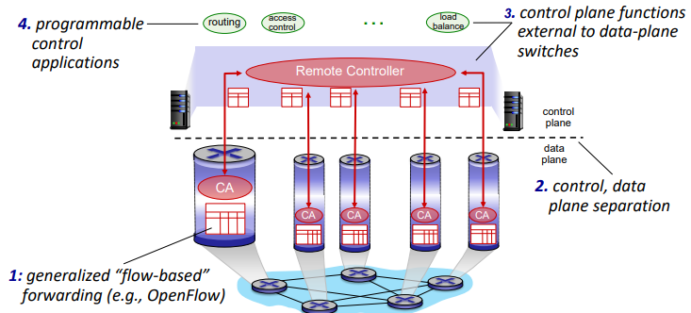

8. SDN Architecture Overview
A. Data Plane (Switches)
- Fast, simple, commodity switches (hardware-based).
- Implement flow-table-based forwarding.
- Controlled via APIs (e.g., OpenFlow).
- Switch’s flow table:
  - Computed and installed by the controller.
  - Specifies match–action rules (e.g., forward, drop, modify).
B. Control Plane (SDN Controller)
- Acts as the Network Operating System (Network OS).
Responsibilities:
- Maintain global network state.
- Provide APIs:
  - Northbound API → For control applications above.
  - Southbound API → For switches below.
- Implemented as a distributed system for:
  - Scalability
  - Fault tolerance
  - Robustness
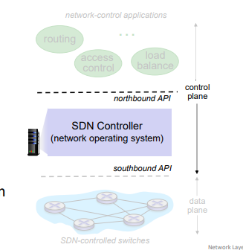
C. Network-Control Applications
- The “brains” of the SDN system.
- Use services from the controller (via APIs) to:
  - Implement routing, load balancing, access control, etc.
- Unbundled software: Can be written by third-party developers, independent of the controller or vendor.

9. Components of an SDN Controller
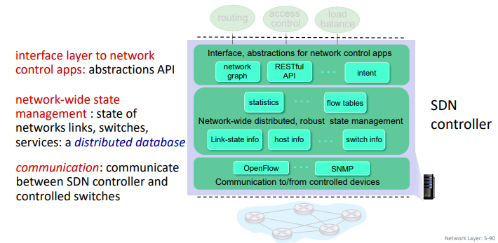

10. OpenFlow Protocol
Purpose
- Standardized protocol between controller and switch.
- Runs over TCP (optionally encrypted).
Three Classes of Messages
- Controller → Switch
- Asynchronous (Switch → Controller)
- Symmetric (Miscellaneous)
Note: OpenFlow protocol ≠ OpenFlow API
API specifies flow rules; protocol defines message exchange.

11. OpenFlow Message Types
Controller → Switch
Message | Function
FEATURES | Query switch capabilities.
CONFIGURE | Set or get switch parameters.
MODIFY-STATE | Add/delete/modify flow entries in tables.
PACKET-OUT | Send specific packets out of selected ports.
Switch → Controller
Message | Function
PACKET-IN | Send packet to controller for decision.
FLOW-REMOVED | Notify controller when flow expires or is deleted.
PORT-STATUS | Inform controller about port state changes.

12. Example: SDN Control/Data Plane Interaction
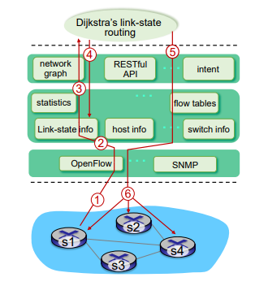
- S1, experiencing link failure uses OpenFlow port status message to notify controller
- SDN controller receives OpenFlow message, updates link status info
- Dijkstra’s routing algorithm application has previously registered to be called when ever link status changes. It is called.
- Dijkstra’s routing algorithm access network graph info, link state info in controller, computes new routes
- Link state routing app interacts with flow-table-computation component in SDN controller, which computes new flow tables needed
- Controller uses OpenFlow to install new tables in switches that need updating

13. ONOS SDN Controller
ONOS (Open Network Operating System)
A distributed, open-source SDN controller designed for scalability and reliability.
Features:
- Separation of network control apps from the core.
- Intent framework:
  - High-level “what” specification instead of “how”.
  - Example: “Connect host A to host B with 1 Gbps QoS.”
- Distributed core:
  - Provides service reliability, replication, and scalability.
Interfaces:
- Northbound: REST API (apps → controller)
- Southbound: OpenFlow, NetConf, OVSDB (controller → devices)
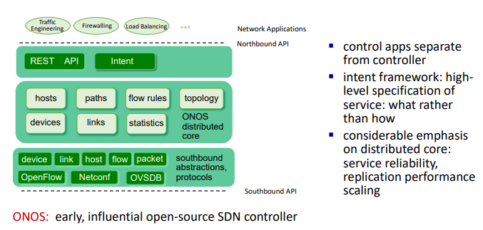

14. Google ORION SDN Control Plane
Overview
- ORION = Google’s SDN control plane (used in data centers (Jupiter) and WAN (B4)).
- Implements:
  - Intra-domain routing, iBGP.
  - Traffic engineering and CoFlow scheduling.
- Architecture:
  - Core built as distributed microservices (pub/sub).
  - Uses OpenFlow for switch signaling and monitoring.
Key Idea
Logical centralization simplifies configuration management.
Benefits (per Google’s engineers):
- All network element roles are pre-defined and centrally managed.
- Eliminates complex per-device configuration.
- Simplifies both technical implementation and human management.

15. SDN: Selected Challenges
Challenge | Description
Control plane reliability | Must be dependable, secure, scalable, and fault-tolerant.
Failure robustness | Use reliable distributed systems theory.
Security and dependability | Should be built in “from day one”.
Mission-specific requirements | Real-time, ultra-reliable, ultra-secure networking (e.g., 5G).
Internet-scale deployment | Extending SDN beyond a single AS.
Integration with 5G | SDN plays a critical role in 5G core and slicing.

16. SDN and Future of Traditional Protocols
Comparison | Description
SDN-computed vs Router-computed forwarding | Centralized computation replaces distributed routing protocols.
Potential evolution | SDN-based congestion control – controller adjusts sender rates based on network feedback.
Big Question | How will implementation of network functionality evolve — centralized SDN or traditional distributed protocols?

- ▪ Internet Control Message Protocol

